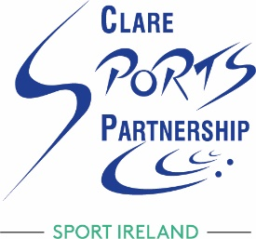
Parental Consent Form Template

LSP Name: Clare Sports Partnership
LSP Contact Person: Catherine Ryan
Workshop: Safeguarding 1
Date of Workshop:

Name of attendee: __________________________
Address: __________________________________
Date of Birth: ______________________________

Name of Parent/Guardian: _________________________
Address: ___________________________________
Contact Number: ___________________________

Parent/Guardian Declaration:
I, (insert name) of (insert address) being the (Parent/Guardian) of (name of attendee) do hereby consent for (name of attendee) to attend and participate in a (name of Safeguarding workshop) on (insert date of workshop).
After signing this, please email it to cathy@claresports.ie

Signed: ___________________
(Parent/Guardian)
Date: ____________________

