Name of Policy | Child Safeguarding Statement
Owner | G&F Manager
Date Approved by Board | 10th December 2025
Signature

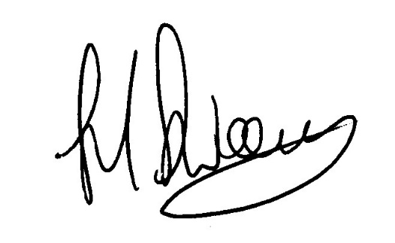  Review Date | September 2027
FILE PATH: | E:\Critical Data\LIVE GOVERNANCE DOCUMENTS\December 2025\Safe Guarding Children.docx

Child Safeguarding Statement
Section 1 –
Clare Local Sports Partnership CLG provides opportunities for young people and vulnerable adults through participation in various organised sporting activities.
Clare Local Sports Partnership CLG ‘s Head Office is based in:
c/o Clare Education Centre
Government Buildings, Kilrush Road, Ennis, Co Clare, V95 F78.

We cater for a number of varied activities throughout the county. The company employs up to 10 persons at any one time.

Section 2 - Principles to safeguard children from harm.
Clare Local Sports Partnership CLG is committed to safeguarding children and by working under the guidance of our Organisation’s Policies our staff, both volunteers and employed, working with our young people, throughout the organisation, seek to create a safe environment for young people to grow and develop within sport. The following set of principles should be adhered to:
- Importance of childhood - The importance of childhood should be understood and valued by everyone involved in sport.
- Needs of the child - All children’s sport experiences should be guided by what is best for children. This means that adults should have a basic understanding of the emotional, physical, and personal needs of young people.
- Integrity in relationships - Adults interacting with children in sport are in a position of trust and influence. They should always ensure that children are treated with integrity and respect, and the self-esteem of young people is enhanced.
- Fair Play - All children’s sport should be conducted in an atmosphere of fair play. The principles of fair play should always be emphasised, and organisers should give clear guidelines regarding acceptable standards of behaviour.
- Quality atmosphere & ethos - Children’s sport should be conducted in a safe, positive, and encouraging atmosphere.
- Competition - Competition is an essential element of sport and should be encouraged in an age-appropriate manner. A child centred ethos will help to ensure that competition and specialisation are kept in their appropriate place.
- Equality - All children should be valued and treated in an equitable and fair manner regardless of ability, age, gender, religion, social and ethnic background, or political persuasion.

Section 3 - Risk Assessment
This Clare Local Sports Partnership CLG Risk Assessment document indicates the areas of potential risk of harm, the likelihood of the risk occurring, and gives the required policy, guidance or process documents require to alleviate these risks. The list of risks identified and procedures to manage these risks are contained in the following categories:
Risk Identified | Procedure in place to manage risk identified
Club and Coaching Practices  - Lack of suitable qualification.  - Supervision issues.  - Unauthorised photography & recording activities.  - Behavioural Issues.  - No guidance for travelling & away trips.  - Lack of adherence with misc. procedures in Safeguarding policy. | - Staff education policy/Recruitment policy.  - Supervision policy/Staff education policy.  - Photography & Use of Images policy.  - Code of Conduct/Safeguarding1/ Complaints & Disciplinary policy.  - Travel/Away trip policy/Child Safeguarding Training.  - Safeguarding Policy/Complaints & disciplinary policy.
Complaints & Discipline  - Lack of awareness of a Complaints & Disciplinary policy.  - Difficulty in raising an issue by child and/or parent or guardian.  - Complaints not being dealt with seriously. | - Complaints & Disciplinary procedure/policy/Communications procedure.  - Complaints & Disciplinary procedure/policy/Communications procedure.  - Complaints & Disciplinary procedure/policy.
Reporting Procedures  - Lack of knowledge of organisational & statutory reporting procedures  - No Designated Laiason Person (DLP) appointed.  - Concerns of abuse or harm not reported.  - Not clear who Young person should talk to or report to. | - Reporting procedures/policy/Staff Education policy/Code of conduct/Behaviour.  - Reporting procedures/policy.  - Reporting procedures/policy/Child Safeguarding 1 Training.  - Post the name of the DLP.
Use of Facilities  - Unauthorised access to designated children’s play, practice areas and to changing rooms, showers, toilets etc.  - Unauthorised exit from children’s areas.  - Photography, filming or recording in prohibited areas.  - Missing or found child on site.  - Children sharing facilities with adults e.g. dressing room, showers etc. | - Supervision policy/Staff Education.  - Supervision policy/Staff Education.  - Photography policy and use of devices in private zones.  - Missing or found child policy.  - Safeguarding policy.
Recruitment  - Recruitment of inappropriate people.  - Lack of clarity on roles.  - Unqualified or untrained people in role. | - Recruitment policy.  - Recruitment policy.  - Recruitment policy.
Communications  - Lack of awareness of ‘risk of harm’ with members and visitors.  - No communication of Child Safeguarding Statement of Code of Behaviour to members of visitors.  - Unauthorised photography and recording of activities.  - Inappropriate use of social media and communications by under 18’s. | - Child Safeguarding Statement / Training Policy.  - Child Safeguarding Statement (display)/Code of Behaviour (distribute).  - Photography and Use of images policy  - Communications policy/Code of conduct.
General Risk of Harm  - Harm not being recognised.  - Harm caused by:  - Child to Child.  - Staff to Child.  - Volunteer to Child.  - Tutor to Child.  - Visitor to Child.  - General behavioural issues.  - Issues of Bullying.  - Vetting of staff/volunteers.  - Issues of Online Safety | - Safeguarding policy/Child Safeguarding Training.  - Safeguarding policy/Child Safeguarding Training.  - Code of Conduct.  - Anti-Bullying policy.  - Safe Recruitment policy/Vetting policy.  - Social Media/Online Safety policy.

The Risk Assessment was undertaken on (insert date).

Section 4 – Procedures
Our Child Safeguarding Statement has been developed in line with requirements under the Children First Act 2015, (the Children First: National Guidance, and Tusla’s Child Safeguarding: A Guide for Policy, Procedure and Practice. In addition to our Risk Assessment document described above, there are further procedures that support our intention to safeguard children while they are availing of our activities.
Clare Local Sports Partnership CLG has the following procedures in place as part of our Safeguarding Policies:
- Procedures for the management of allegations of abuse or misconduct by staff or volunteers against a child availing of our activities.
- Procedures for the safe recruitment of staff and volunteers to work with children in our activities.
- Procedures for access to child safeguarding training and information, including the identification of the occurrence of harm.
- Procedure for reporting of child protection or welfare concerns to Statutory Authorities.
- Procedure for maintaining a list of the persons (if any) in the relevant service who are mandated persons.
- Procedure for appointing a relevant person.
Please note that all procedures listed are available on request.
The Relevant Person for Club/Organisation/NGB is John Sweeney

Section 5 – Implementation
We recognise that implementation is an ongoing process. Our Club/Organisation/NGB is committed to the implementation of this Child Safeguarding Statement and the procedures that support our intention to keep children safe from harm while availing of our activities.
Please note the following:
- That all staff and volunteers have been furnished with a copy of this statement.
- This statement is available to parents/guardians, the Agency, and members of the public on request.
- This statement will be displayed in a prominent place by the Club/Organisation/NGB.
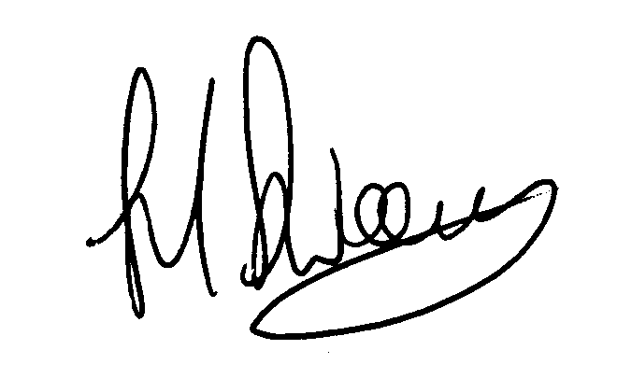
This Child Safeguarding Statement will be reviewed on September 2027
Signed: Date: 10/12/2025
(On behalf of the Clare Local Sports Partnership CLG – this is the Provider)
Name: John Sweeney Phone no: 065 6865434
For queries on this Child Safeguarding Statement, please contact John Sweeney

